📊 Pivot Table Explanations
1. Total Budget by Service
This pivot table represents the total budget distributed across all services in the dataset. It shows how much budget is allocated and generated by different services. The overall total budget recorded is $297,900.00.
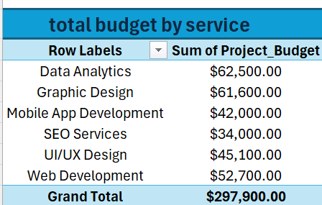

2. Number of Clients by City
This pivot table shows the distribution of clients across different cities. It helps to understand how clients are spread geographically. The dataset contains a total of 50 clients.
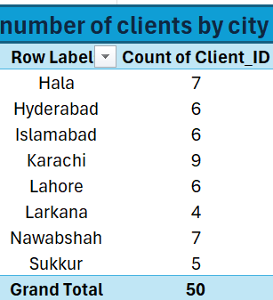
3. Project Status Count
This pivot table displays the number of projects based on their current status. It gives a clear view of how many projects are completed or in progress. The total number of project records is 50.

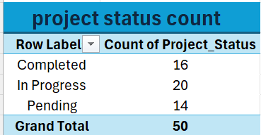

4. Lead Source Performance
This pivot table shows how clients are coming from different lead sources. It helps to identify which sources are more effective in generating clients. A total of 50 records are included.

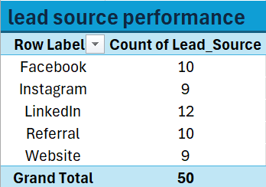

5. Payment Status Summary
This pivot table summarizes the payment status of all projects. It helps in tracking paid and pending records. The dataset includes 50 total payment entries.
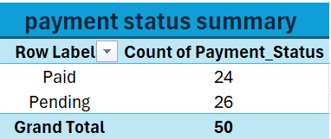

6. Average Rating by Service
This pivot table shows the average rating received by each service. It helps in understanding the performance and satisfaction level of clients. The overall average rating is 214.4.

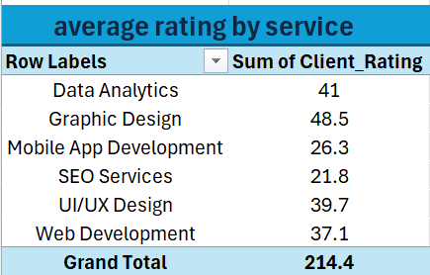

Key Findings
- The total budget across all services is $297,900.00.
- The dataset includes 50 client records in total.
- All categories such as projects, leads, and payments contain 50 entries.
- Different services contribute differently to the overall budget.
- Client ratings show an overall average performance of services.

